猪肉：

东坡肉

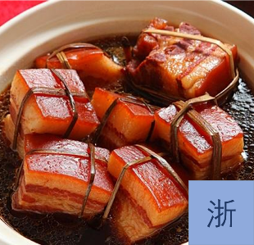

营养成分：每100 克 - 卡路里: 463千卡

食材：[猪五花肉](https://www.meishichina.com/YuanLiao/WuHuaRou/)

配料：[八角](https://www.meishichina.com/YuanLiao/BaJiao/)[冰糖](https://www.meishichina.com/YuanLiao/BingTang/)，黄酒，[酱油](https://www.meishichina.com/YuanLiao/JiangYou/)，[香葱](https://www.meishichina.com/YuanLiao/XiangCong/)，[大葱](https://www.meishichina.com/YuanLiao/DaCong/)，[生姜](https://www.meishichina.com/YuanLiao/SHENGJIANG/)

步骤：

1.先将五花肉洗净

2.入开水锅里煮8分钟左右

3.捞出晾凉后切成3cm左右的方块

4.锅底用几段竹筷搭成井子垫底，摆上香葱

5.放上姜片，把肉块皮朝下摆好，近量摆的密实些塞满最好

6. 加入老抽和鲜味酱油，倒上老黄酒，放上冰糖，大火烧开改小火慢炖2小时

7. 时间到，取出皮朝上放入一带盖得容器内，大火蒸1小时取出

8. 将炖肉时候的汤汁烧开加水淀粉勾芡，浇在蒸好的肉上即可

Nutritional composition: per 100 g - calories: 463 kcal

Ingredients: Pork

Ingredients: star anise, rock sugar, yellow wine, soy sauce, shallots, scallions, ginger

Steps.

1. Wash the pork first

2. Boil in a pot of boiling water for about 8 minutes

3. Remove and cool, then cut into 3cm cubes

4. Bottom of the pot with a few pieces of bamboo chopsticks built into the bottom of the well, arrange the scallions

5. Put ginger slices, place the meat pieces skin side down, nearly the amount of the dense arrangement of the best stuffed

6. add soy sauce and fresh soy sauce, pour on the old yellow wine, put on the rock sugar, high heat boil to low heat and slow stew for 2 hours

7. time, take out the skin side up into a container with a lid, steam for 1 hour to remove

8. boil the soup when stewing meat, add water starch thickening, pour on the steamed meat can be

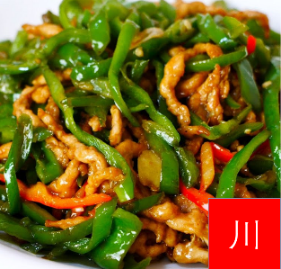

青椒肉丝

营养成分：每100 克 - 卡路里: 101千卡

食材：青椒，猪肉

配料：酱油30克，香油50克，鸡汤75毫升，淀粉75克，芝麻5克，盐适量、姜、蒜、生抽、料酒、胡椒粉、糖

步骤：1. 青椒洗净切成3厘米长的细丝,放入盐腌渍片刻。

2. 花猪肉洗净，切成长3厘米，宽5毫米，厚5毫米的丝，与盐、40克淀粉搅拌均匀，腌渍入味。

3. 把酱油、35克淀粉放入碗内，加鸡汤勾兑成芡汁。

4. 炒锅烧热,加油烧到7成热,倒入青椒，用大火翻炒，取出；

5. 再放入25克香油，烧热，放入肉丝，煸炒几下，倒入青椒丝，加入少量淀粉水，翻炒几下起锅，撒上焙好的芝麻，即可。

Shredded pork with green pepper

Nutritional composition: per 100 g - calories: 101 kcal

Ingredients: green pepper, pork

Ingredients: 30g soy sauce, 50g sesame oil, 75ml chicken broth, 75g cornstarch, 5g sesame seeds, salt, ginger, garlic, soy sauce, cooking wine, pepper, sugar

Step: 1. Wash and cut green pepper into 3 cm long julienne strips and marinate in salt for a few minutes.

2. Wash the pork, cut into 3 cm long, 5 mm wide and 5 mm thick shreds, mix with salt and 40 grams of cornstarch and marinate for a while.

3. Put soy sauce and 35g starch into a bowl and thicken with chicken broth to make gravy. 4.

4. heat a frying pan, add oil and heat to 70%, pour in the peppers, stir-fry over high heat and remove.

5. Add 25 grams of sesame oil, heat, add the shredded meat, stir-fry a few times, pour in the shredded peppers, add a small amount of cornstarch, stir-fry a few times, sprinkle with roasted sesame seeds, ready.

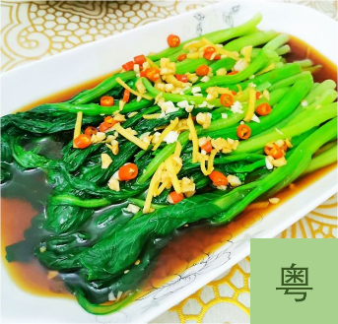

白灼菜心

营养成分： 每100 克 - 卡路里: 11千卡

食材： 广东菜心

配料：盐、鸡精，淀粉，葱，红椒

步骤：1、烧开半锅水，加少量盐和油，入菜心焯制1分钟左右；

2、将焯好的菜心整齐码放在盘中，红椒和葱切丝待用；

3、锅内入油烧热，放入适量蚝油和鲜味汁，加入红椒丝和高汤煮至轻微沸腾，勾放少许水淀粉；

4、将红椒丝和葱丝码放在菜心上，将汤汁淋在菜心上即可。

Roasted Cabbage

Nutrition Facts: Per 100g - Calories: 11kcal

Ingredients: Cantonese cabbage heart

Ingredients: salt, chicken seasoning, starch, green onion, red pepper

Steps: 1. Boil half a pot of water, add a little salt and oil, and blanch the heart of vegetables for about 1 minute.

2, the blanched heart of vegetables neatly arranged in a dish, red pepper and green onion shredded for use;.

3、Heat oil in a pot, put in an appropriate amount of oyster sauce and fresh flavor sauce, add shredded red pepper and stock and cook until slightly boiling, hook a little water starch.

4, the shredded red pepper and green onion yard on the heart of vegetables, the soup will be dripping on the heart of vegetables.

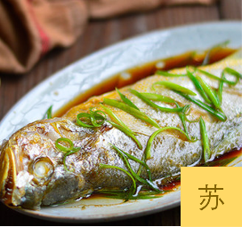

清蒸黄花鱼

营养成分： 每100克 - 卡路里: 209千卡

食材： 黄花鱼

配料：姜、葱、蒸鱼豉油、盐

步骤：

1、准备好所有的食材。

2、姜切一半切成片，一半切成丝，葱白切段，萄叶切未。盘子底部铺上葱段与姜片。[1]

3、黄花鱼收搭开，对剖开，鱼身抹上薄薄的一层盐腌制10分钟，摆上盘，鱼身上再摆上切好的姜丝。

4、锅内水烧开后把腌好的鱼放入锅内，大火蒸七分钟。

5、出锅后倒掉盘内蒸出的水份。

6、调两大勺蒸鱼豉油。

7、撒上切好的葱花。

8、另起锅烧热两勺食用油淋在鱼身上即可

Steamed Yellow Croaker

Nutrition Facts: Per 100g - Calories: 209kcal

Ingredients: Yellow croaker

Ingredients: ginger, green onion, steamed fish soya sauce, salt

Steps.

1, prepare all the ingredients.

2, ginger cut half into slices, half cut into shreds, white onion cut into sections, cut the leaves of the electrum not. Lay the bottom of the plate with green onion segments with ginger slices. [1]

3, yellow croaker collection hitch open, to cut open, the fish body smeared with a thin layer of salt marinated for 10 minutes, laid on the plate, the fish and then laid on the shredded ginger cut.

4, the pot of water boiling and put the marinated fish into the pot, steam for seven minutes on high heat.

5, out of the pot and pour off the water steamed out of the dish.

6、Two tablespoons of steamed fish soy sauce.

7, sprinkle with chopped green onion.

8, another pot to heat up two spoons of cooking oil drizzled on the fish.

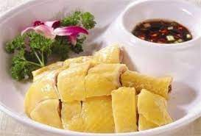

文昌椰子鸡 粤菜

营养成分： 每100克 - 卡路里:144千卡

食材： 鸡腿肉

配料：酱油，大葱 ，姜 ，大蒜，白砂糖，香油，醋

步骤：

1. 鸡腿洗净，先氽烫过，再用清水煮熟，水中放2根葱、2片姜同煮；

2. 鸡腿煮好捞出放凉，剁小块放入盘内；

3. 将葱、姜、大蒜和辣椒全部切碎，用2大匙油炒香，并加入所有调味料煮匀，盛出，淋在鸡腿上即成。

Wenchang Coconut Chicken Cantonese Cuisine

Nutrition Facts: Per 100g - Calories:144kcal

Ingredients: Chicken thigh meat

Ingredients: soy sauce, onion, ginger, garlic, sugar, sesame oil, vinegar

Steps.

1. wash the chicken thighs, blanch them first, then boil them in water, put 2 scallions and 2 slices of ginger in the water and cook them together.

2. cook the chicken thighs and let them cool, chop them into small pieces and put them on a plate.

3. Chop the green onion, ginger, garlic and chili, stir-fry with 2 tbsp oil and add all the seasonings, cook well, serve and pour over the chicken thighs.

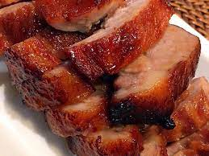

蜜汁叉烧 粤菜

营养成分： 每100克 - 卡路里:206千卡

食材： 五花肉

配料：叉烧酱，蚝油，生抽，姜丝，蜂蜜

步骤：

1、五花肉去皮洗净后，切开两段

2、放入干净干爽的保鲜盒里，洒上姜丝

3、倒入2匙羹叉烧酱，1匙羹生抽，1匙羹耗油

4、拌匀后盖盖子，冷藏腌制两天，期间要翻肉多次，让肉充分入味

5、两天后从冰箱取出肉，解冻半小时

6、预热烤箱，上下火190°，不粘烤盘上垫锡纸，把肉和少许的汁放上去，送进烤箱中层烤30分钟

7、5分钟翻面一次，10分钟后再开始刷蜂蜜，出炉前在刷一层蜂蜜

8、出炉后待温度稍降后，开始切片

BBQ Pork with Honey Sauce Cantonese Cuisine

Nutrition Facts: Per 100g - Calories:206kcal

Ingredients: Pork

Ingredients: barbecue sauce, oyster sauce, soy sauce, shredded ginger, honey

Steps

1, pancetta peeled and washed, cut two sections

2: Place in a clean and dry plastic container and sprinkle with shredded ginger.

3: Pour in 2 tablespoons barbecue sauce, 1 tablespoon soy sauce and 1 tablespoon cooking oil.

4, mix well and cover, refrigerate and marinate for two days, turn the meat several times during the period, so that the meat is fully flavored

5: After two days, remove the meat from the refrigerator and defrost for half an hour.

6, preheat the oven, the upper and lower heat 190 °, non-stick baking sheet lined with tin foil, put the meat and a little juice on it, sent to the middle of the oven to bake 30 minutes

7, 5 minutes to flip once, 10 minutes and then start brushing honey, brush a layer of honey before taking out of the oven

8, out of the oven and wait for the temperature to drop slightly, start slicing

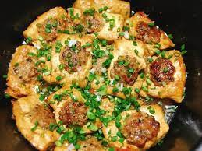

客家酿豆腐 粤菜

营养成分： 每100克 - 卡路里: 89千卡

食材：豆腐、猪肉末，鸡蛋

配料：香菜末、葱花、淀粉、白糖、盐、剁椒、蚝油、酱油

步骤：

1、在猪肉末中加入葱花、鸡蛋液、盐、酱油搅拌均匀；

2、把三角油豆腐对半切，中间挖空，塞入搅拌好的肉末，然后抹平；

3、包好的油豆腐塞肉放入冷水锅煮；

4、用香菜末、剁椒、蚝油、白糖和适量清水混合成调料，并加入一点煮油豆腐的水勾芡，倒入锅中一起煮即可。

Hakka Stuffed Tofu Cantonese Cuisine

Nutrition Facts: Per 100g - Calories: 89kcal

Ingredients: tofu, minced pork, egg

Ingredients: minced cilantro, chopped green onion, cornstarch, sugar, salt, chopped pepper, oyster sauce, soy sauce

Steps.

1、Add chopped green onion, egg mixture, salt and soy sauce to the minced pork and mix well.

2, cut the triangle of oil tofu in half, hollow out the middle, stuff it with the stirred minced pork and smooth it out.

3, wrap the oiled tofu stuffed with meat into a pot of cold water and cook.

4, mix the seasoning with minced cilantro, chopped pepper, oyster sauce, sugar and appropriate amount of water, and add a little of the water used to cook the oil tofu to thicken it, pour it into the pot and cook together.

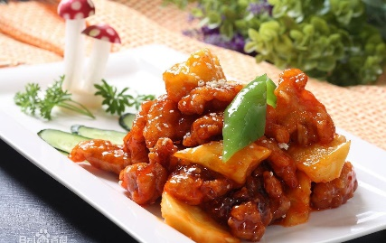

糖醋咕噜肉 粤菜

营养成分： 每100克 - 卡路里267千卡

食材：豆腐、猪肉末，鸡蛋

配料：香菜末、葱花、淀粉、白糖、盐、剁椒、蚝油、酱油

步骤：

1新鲜里脊肉切成长条。用盐，料酒把肉腌入味，再裹上蛋清和淀粉。

2锅内倒入西班牙橄榄油，等待油6成熟后，放入肉块炸至五成熟出沥干。

3锅留底油爆香蒜和辣椒，加葱，番茄酱炒匀。

4倒入倒入肉片拌炒，放醋，勾芡，装盘。

Sweet and Sour Goulash Cantonese Cuisine

Nutritional composition: per 100g - 267kcal

Ingredients: tofu, minced pork, egg

Ingredients: minced cilantro, chopped green onion, starch, sugar, salt, chopped pepper, oyster sauce, soy sauce

Steps.

1 Fresh tenderloin meat cut into long strips. Marinate the meat with salt and wine, then coat with egg white and cornstarch.

2 Pour Spanish olive oil into the pan, wait until the oil is 6 mature, then add the meat and fry it until it is fifty percent dry.

3 pan oil left to pop garlic and pepper, add shallots, tomato sauce and sauté well.

4 Pour into the meat and stir-fry, put vinegar, thicken, plate.

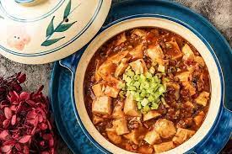

麻婆豆腐 川菜

营养成分： 每100克 - 卡路里119千卡

食材：豆腐，牛肉末

配料：青蒜末，姜蒜末，食用油，盐，酱油，红油豆瓣酱，豆鼓，辣椒粉，花椒粉，鸡精，料酒

步骤：

1，准备好材料，牛肉提前剁成末

2，牛肉用盐、酱油、料酒搅拌均匀腌制10分钟

3，豆腐切块，放开水中焯水，水开后煮5分钟

4，热锅凉油，加入姜蒜末煸炒出香味后加入牛肉煸炒至变色

5，加入剁碎的豆鼓、红油豆瓣酱、辣椒粉炒匀

6，加入少量水后放入焯过水的豆腐焖煮十分钟

7，加入花椒粉、鸡精炒匀后加点水淀粉搅拌均匀后装盘，撒上青蒜末即可

Ma Po Tofu Sichuan Cuisine

Nutrition Facts: Per 100g - 119kcal

Ingredients: tofu, minced beef

Ingredients: minced green garlic, minced ginger and garlic, cooking oil, salt, soy sauce, red oil bean paste, bean drums, chili powder, pepper powder, chicken seasoning, cooking wine

Steps.

1, prepare the materials, beef chopped into minced in advance

2, beef with salt, soy sauce, cooking wine stir well marinated for 10 minutes

3, tofu cut into pieces, let go of water blanching, boil water and cook for 5 minutes

4, hot pan with cool oil, add ginger and garlic stir-fried aroma and add beef stir-fried until browned

5, add chopped bean drums, red oil bean paste, chili powder stir-fry well

6, add a small amount of water and then add blanched tofu and simmer for ten minutes

7, add pepper powder, chicken seasoning stir-fry well, add some water starch and stir well, then plate, sprinkle with minced green garlic can be

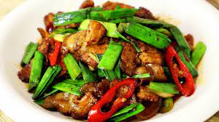

回锅肉 川菜

营养成分： 每100克 - 卡路里415千卡

食材：五花肉，青椒，青蒜，红椒

配料：郫县豆瓣酱，豆豉，白糖，鸡精，花生油

步骤：

1，冷水下肉，大火烧开，煮至肉刚熟即可，待肉凉后切成薄片。

2，冷水下肉，大火烧开，煮至肉刚熟即可（用筷子可以穿透不渗血水），待肉凉后切成薄片。

3，起油锅，下肉片煸炒。

4，待肉片出油有点卷的时候，下郫县豆瓣酱炒匀

5，再加入切碎的豆豉炒香。

6，加入青红椒，炒至断青

7，最后，加入青蒜炒出香味。

8，最后，再加入糖，鸡精调味就可以出锅了

Backpot Pork Sichuan Cuisine

Nutrition Facts: Per 100g - 415kcal

Ingredients: Pork, green pepper, green garlic, red pepper

Ingredients: Pixian bean paste, black bean paste, sugar, chicken essence, peanut oil

Steps.

1, cold water under the meat, boil over high heat, cook until the meat is just cooked, and then cut into thin slices after the meat is cool.

2, cold water under the meat, boil over high heat, cook until the meat is just cooked (with chopsticks can penetrate without seeping blood), and then cut into thin slices after the meat cools.

3, frying pan, stir-fry the meat slices.

4, to be a little volume of meat out of the oil, under the PI County bean paste stir-fry well

5, then add the chopped tempeh stir-fry.

6, add green and red pepper, stir-fry until broken green

7, finally, add the green garlic stir-fried aroma.

8, finally, then add sugar, chicken seasoning can be removed from the pot

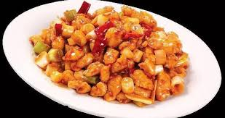

宫保鸡丁 川菜

营养成分： 每100克 - 卡路里268千卡

食材：鸡胸肉，大葱，油炸花生米，辣椒段

配料：盐，生抽，老抽，香醋，糖，姜汁，蒜泥，鸡精，花椒粉，白胡椒，料酒

步骤：

1，鸡胸肉用刀背拍一下，切成大拇指甲大小的丁。

2，用料酒一汤匙，食用油半汤匙，白胡椒半茶匙，盐半茶匙，淀粉一茶匙，腌渍十分钟入味。

3，葱切段。

4，锅里放油，七八成热下鸡丁炒变白。

5，放入干辣椒，葱和一茶匙花椒粉，炒出香味。

6，兑入料汁，大火炒到粘稠干松即可。

7，关火，拌入花生米即可。

Kung Pao Chicken Sichuan Cuisine

Nutrition Facts: Per 100g - 268kcal

Ingredients: chicken breast, green onion, fried peanut rice, chili pepper segments

Ingredients: salt, soy sauce, soy sauce, balsamic vinegar, sugar, ginger juice, garlic paste, chicken essence, pepper powder, white pepper, cooking wine

Steps.

1, Pat the chicken breast with the back of a knife and cut into thumbnail-sized dice.

2: Marinate with 1 tablespoon cooking wine, ½ tablespoon cooking oil, ½ teaspoon white pepper, ½ teaspoon salt and 1 teaspoon cornstarch for 10 minutes to taste.

3, Cut green onion into pieces.

4: Heat oil in a pot and stir-fry the diced chicken at 70% to 80% heat.

5: Add dried chili, green onion and a teaspoon of pepper and stir-fry to bring out the fragrance.

6, blend into the sauce, high heat stir-fry until sticky dry loose.

7, turn off the heat, mix in the peanut rice.

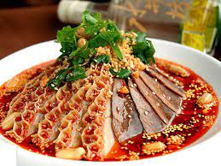

夫妻肺片 川菜

营养成分： 每100克 - 卡路里138千卡

食材：牛腱，牛肚，牛舌，牛筋，牛心，芝麻，无皮花生

配料：辣椒粉，辣椒碎，花椒，丁香，桂皮，小茴香，草果，八角，香叶，生姜，葱头，紫草，色拉油，酱油，老抽，冰糖，红糖

步骤：

1，熬红油准备材料：辣椒粉4/3杯、辣椒碎1/4杯（1杯=250毫升下同）、花椒1大勺、丁香3颗、桂皮小半条、小茴香1小勺、草果1颗、八角4颗、香叶3片、生姜1小块、葱头3段、芝麻1大勺、紫草1小段（以上材料如图）。再加200克无皮花生和600克的色拉油（或蔬菜油）。

2，油倒入锅内，油温微热时加入花生，用文火炸至微黄酥脆

3，捞出，部分可作为配料

4，将上述其它材料（除芝麻外）放入油锅，立即转最小的火力。熬1个小时后，加入芝麻，再熬15分钟。

5，油锅里的所有材料倒入一个碗内。

6，浸泡1天后，去除残渣，沥出红油。保存可多次使用。

7，熬酱油准备材料：酱油1杯、老抽3大勺、冰糖1小块、红糖3大勺、花椒、八角、小茴香、香叶、生姜、葱头。以上所有材料见图。

8，所有材料放入锅里，烧开后转文火熬30分钟。

9，将残渣过滤出来。

10，酱油装入容器保存，可多次使用。

11，第三步：煮牛杂和调制红油汁水没过牛杂，加适量的料酒、盐、八角、葱姜将牛杂煮至微烂。可以把其中难熟的部分如牛腱、牛筋等用压力锅煮。

12，煮好的牛杂取出放凉后，切成薄片，放在有点深度的碗里。

13，准备高汤，用盐和鸡精调味（我用的是清鸡汤已经有味道了）

14，调制红油汁：比例大约是：红油半杯、高汤半杯、熬过的酱油3大勺、花椒粉半小勺、麻油1大勺、盐半小勺。

15，将调好的红油汁浇在牛杂上（红油汁的量掌握在能把牛杂浸泡在其中），加上葱花、香菜和炸过的花生碎。

Couple's Lung Slices Sichuan Cuisine

Nutrition Facts: Per 100g - 138kcal

Ingredients: beef tendon, beef tripe, beef tongue, beef tendon, beef heart, sesame seeds, peanuts without skin

Ingredients: chili powder, ground chili pepper, peppercorns, cloves, cinnamon, cumin, herb nuts, star anise, allspice, ginger, scallions, comfrey, salad oil, soy sauce, soy sauce, rock sugar, brown sugar

Steps.

1, boiling red oil preparation materials: chili powder 4/3 cup, chili pepper 1/4 cup (1 cup = 250 ml the same below), pepper 1 tablespoon, cloves 3, cinnamon half a small strip, cumin 1 small spoon, grass fruit 1, star anise 4, allspice 3 pieces, ginger 1 small piece, green onion 3 sections, sesame 1 tablespoon, comfrey 1 small section (the above materials as shown). Add 200 grams of peanuts without skin and 600 grams of salad oil (or vegetable oil).

2, oil poured into the pan, oil temperature slightly hot add peanuts, fry over moderate heat until slightly yellow and crispy

3, fish out, part can be used as ingredients

4, add the other ingredients listed above (except sesame seeds) to the frying pan and immediately turn to the lowest heat. Simmer for 1 hour, then add sesame seeds and simmer for another 15 minutes.

5, Pour all the ingredients in the frying pan into a bowl.

6, After soaking for 1 day, remove the residue and drain out the red oil. Save for multiple use.

7, boil soy sauce preparation materials: 1 cup of soy sauce, 3 tablespoons of soy sauce, 1 small piece of rock sugar, 3 tablespoons of brown sugar, peppercorns, star anise, cumin, allspice, ginger, scallions. All the above ingredients are shown in the picture.

8, all the ingredients into the pot, boil and turn to simmer for 30 minutes.

9, strain out the residue.

10, soy sauce into a container to save, can be used many times.

11, the third step: cooking beef and modulating red oil sauce water not over the beef, add the right amount of cooking wine, salt, star anise, green onions and ginger will be cooked until slightly rotten. Can be difficult to cook parts such as tendons, tendons, etc. cooked in a pressure cooker.

12, cooked beef miscellaneous removed and cooled, cut into thin slices and placed in a bowl of some depth.

13, prepare stock, season with salt and chicken seasoning (I used clear chicken stock already has a taste)

14, make red oil sauce: the ratio is about: red oil half a cup, half a cup of stock, boiled soy sauce 3 tablespoons, pepper powder half a small spoon, sesame oil 1 tablespoon, salt half a small spoon.

15, the seasoned red oil sauce poured on the beef (the amount of red oil sauce to grasp the amount of beef can be soaked in it), plus chopped green onions, cilantro and fried peanuts.

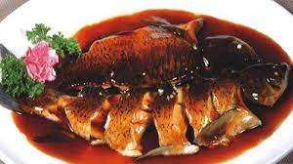

西湖醋鱼 浙菜

营养成分： 每100克 - 卡路里122千卡

食材：草鱼

配料：辣椒粉，辣椒碎，花椒，丁香，桂皮，小茴香，草果，八角，香叶，生姜，葱头，紫草，色拉油，酱油，老抽，冰糖，红糖

步骤：